

**FINAL REPORT**

***Digital Lawyer Street***

**Submitted by**

*Anas Makki (2018-GCUF-058102)*

*Abdul Rahman (2018-GCUF-058166)*



**Department of Computer Science  
Govt. Graduate College Samanabad Faisalabad**

**2022**

**CERTIFICATE**

This is to certify that ***Anas Makki & Abdul Rehman*** bearing Registration No. ***2018-GCUF-058102 & 2018-GCUF-058166*** has completed the final project titled as ***“Digital Lawyer Street”*** at the **Department of Computer Science**, **Govt. Graduate College Samanabad Faisalabad**, to fulfill the partialrequirement for the degree of ***BS - CS****.*

**Supervisor**

**Sir Ghulam Mustafa** **Signature: ____________**

**Co-Supervisors**

**Member 1: Mam Sania** **Signature: ____________**

**Member 2: Mam Qoseen** **Signature: ____________**

**Member 3: Mam Ambreen** **Signature: ____________**

**External Supervisor**

**Supervisor Name:** **Signature: ____________**

**Project Coordinator Head of Department**

**Principal**

**DECLARATION**

The work reported in this project was carried by me under the supervision of **Project Supervisor**, **Sir Ghulam Mustafa**, at **Government Graduate College Samanabad Faisalabad**.

I hereby declare that this project and the contents of project are the product of my own research and no part has been copied from any other written or published source (accept the references, standard mathematical or genetics models / equation / formulas / protocol etc.).

I further declare that this work has not been submitted for award of any other degree / diploma.

The institution may take action if the provided information is found inaccurate at any stage.

**Name : Anas Makki**

**Registration No. : 2018-GCUF-058102**

**Name : Abdul Rahman Registration No. : 2018-GCUF-058166**

**ACKNOWLEDGEMENT**

I thank all who in one way or another contributed in the completion of this report. First, I thank to ALLAH ALMIGHTY, most magnificent and most merciful, for all his blessings. Then I am so grateful to the Department of Computer Science of Govt. Graduate College Samanabad Faisalabad for making it possible for me to study here. My special and heartily thanks to my supervisor, Sir. Ghulam Mustafa who encouraged and directed me. His challenges brought this work towards a completion. It is with his supervision that this work came into existence. For any faults I take full responsibility. I am also deeply thankful to my informants. I want to acknowledge and appreciate their help and transparency during my research. I am also so thankful to my fellow students whose challenges and productive critics have provided new ideas to the work. Furthermore, I also thank my family who encouraged me and prayed for me throughout the time of my research. May ALLAH Almighty richly bless all of you [Ameen]

**ABSTRACT**

As the world increasingly progresses towards a technology driven environment, the legal sector is not to be left behind. In the past years, clients got to know about lawyers through recommendation and at the same time lawyers had a challenge reaching out to their clients. Work was slow and tedious as research was conducted on dusty and old textbooks.

The basis of this project is to bridge the technology gap between the lawyers and advocates in Pakistan. Lawyers that deal with legal services will most likely handle huge quantum of inventory and have to make sure that these files are readily available when it is required. It has therefore become necessary for these firms to employ a method that will securely handle this large data and readily avail it to more than one person at a time even though they are in different locations. The goal of this project is to develop an application that will aid lawyers to handle cases from wherever they are, and quickly generate reports.

**Table of Contents**

Chapter 1 1

1.1 Purpose 1

1.2 How it works 1

1.2.1 Register Lawyer 1

1.2.2 Evaluate Lawyers 1

1.2.3 Feedbacks 1

1.2.4 Queries 1

1.2.5 Register Client 2

1.2.6 Case Information 2

1.2.7 Appointment 2

1.2.8 Hire Staff 2

1.3 Project Scope 2

1.4 Project Planning 2

1.5 Project Modules 4

1.5.1 Admin Module: 4

1.5.2 Lawyer Module: 4

1.5.3 User (Client) Module: 4

1.5.4 Team Member Module: 4

Chapter 2 Background 5

2.1 Background Research 5

2.2 Existing Technology 5

2.3 Area of Study 6

2.4 Reason of the Project 6

2.4.1 Accuracy of Information 6

2.4.2 Efficiency 7

2.4.3 Easy to Use 8

2.4.4 Security 8

2.4.5 User Friendly 9

2.4.6 Time Saving 9

2.5 Objective of the project 9

2.6 Methodology 10

Chapter 3 System Requirement Analysis 11

3.1 System Functional Requirements 11

3.1.1 Project Interactivity Plan 11

3.1.2 Signup Information 11

3.1.3 Login Information 11

3.1.4 Lawyer Record 11

3.1.5 SRS Document (System Requirements Specification) 13

3.2 Non-Functional Requirements of the system 13

3.3 Hardware & Software Requirements 14

3.3.1 Software Requirements 14

3.3.2 Hardware Requirements 14

3.4 Introduction of Tools 15

3.4.1 VS Code 15

3.4.2 HTML (Hyper Text Markup Language) 15

3.4.3 CSS (Cascading Style Sheet) 16

3.4.4 Bootstrap 16

3.4.5 JavaScript 17

3.4.6 JQuery 17

3.4.7 PHP 18

3.4.8 AJAX 18

3.4.9 MySQL 19

Chapter 4 System Design 20

4.1 Use case – fully dressed 20

4.1.1 Importance of Use Case Diagrams 20

4.1.2 Use Case Diagram objects 20

4.1.3 Use Case Diagram 22

4.2 WBS fully dressed 24

4.3 System Sequence diagram 24

4.4 Class diagram 25

4.5 ER (Entity Relationship Model) Model 27

4.6 Data Flow Diagram 27

4.6.1 Symbols and Notations Used in DFDs 28

4.6.2 Data Flow Diagram of Digital Lawyer Street (DLS) 28

Chapter 5 Testing & Implementation 31

5.1 Testing Methods 31

5.2 Functional vs. non-functional testing 31

5.2.1 Functional Testing 32

5.2.2 Non- functional Testing 35

5.3 Test Cases 38

5.3.2 Function testing 40

5.3.4 Performance Testing 42

Chapter 6 User Manual 43

6.1 Main/Home view 43

6.2 Our Lawyers Page 43

6.3 Services Page 44

6.4 Testimonial Page 44

6.5 About Us Page 45

6.6 Contact Us Page 45

6.7 Footer 45

6.8 DLS Statistics 46

6.9 Forget Password 46

6.10 Lawyer Registration Page 47

6.11 User Login 48

6.12 User Dashboard 48

6.13 Lawyer Dashboard 49

6.14 Lawyer Requests 49

6.15 List of Lawyers 50

6.16 Database Connection 50

6.17 Front End Coding 51

6.18 Backend Coding 52

6.19 Database 52

6.20 Database Table Structure 53

**List of Tables**

Table 1: Software Requirement Specification 13

Table 2: Software Requirements 14

Table 3: Hardware Requirements 14

Table 4: Data Integrity 39

Table 5: Function Testing 40

Table 6: User Interface Testing 41

**List of Figures**

Figure 1: SLDC Waterfall Model 3

Figure 2: Accuracy 7

Figure 3: Efficiency 7

Figure 4: Easy to Use 8

Figure 5: Security 8

Figure 6: User Friendly 9

Figure 7: Time Saving 9

Figure 8: Visual Studio Code 15

Figure 9: HTML (Hyper Text Markup Language) 15

Figure 10: CSS (Cascading Style Sheet) 16

Figure 11: Bootstrap 16

Figure 12: JavaScript 17

Figure 13: jQuery 17

Figure 14: PHP 18

Figure 15: AJAX 19

Figure 16: MySQL 19

Figure 17: Actor 21

Figure 18: Use Case 21

Figure 19: System 21

Figure 20: Package 22

Figure 21: Relationships 22

Figure 22: Use Case Diagram 23

Figure 23: WBS (Work Breakdown Structure) 24

Figure 24: Sequence Diagram 25

Figure 25: Class Diagram 26

Figure 26: ER (Entity Relationship Diagram) 27

Figure 27: DFD Types 28

Figure 28: Context Level DFD 28

Figure 29: Level 1 DFD 29

Figure 30: Level 2 DFD 30

Figure 31: Functional Testing 32

Figure 32: Unit Testing 33

Figure 33: Integration Testing 34

Figure 34: System Testing 34

Figure 35: Acceptance Testing 35

Figure 36: Load Testing 36

Figure 37: Stress Testing 36

Figure 38: Compatibility Testing 38

Figure 39: Home Screen 43

Figure 40: Lawyers Page 43

Figure 41: Services 44

Figure 42: Testimonials 44

Figure 43: About Us 45

Figure 44: Contact Us 45

Figure 45: Footer 45

Figure 46: DLS Statistics 46

Figure 47: Forget Password 46

Figure 48: Lawyer Registration 47

Figure 49: Login Area 48

Figure 50: User Dashboard 48

Figure 51: Lawyer Dashboard 49

Figure 52: Lawyer List 50

Figure 53: Database Connection 50

Figure 54: Front End 51

Figure 55: Back End 52

Figure 56: Database 52

Figure 57: Table Structure 53

Chapter 1 Introduction

## 1.1 Purpose

The current scenario used by the lawyers in maintaining heavy files works for keeping the records of their cases. **Digital Lawyer Street** is a new website for people to find lawyers via the use of the internet and also for the lawyers to maintain records of the cases they are dealing with. A lot of people need to contact their lawyers regularly or find appropriate lawyers for their cases. The goal of the project is to provide a flexible way for people to fulfill their requirements. The admin of the website can register/approve different Lawyers and each lawyer can in turn register his/clients and even his/her staff members. The lawyers and clients can work out their cases. This site provides a flexible way for lawyers and clients to handle their cases in a well-formatted way online through any part of Pakistan.

## 1.2 How it works

### 1.2.1 Register Lawyer

**Digital Lawyer Street** application hires lawyers in different practice areas. Admin verify requested lawyers on this system. On DLS registered lawyers receive the cases that clients apply or request and manage the case for whom clients hire.

### 1.2.2 Evaluate Lawyers

Admin is responsible to evaluate the lawyers by checking and verifying their **License Numbers** or any other evaluation method.

### 1.2.3 Feedbacks

Clients on DLS can give feedback about our system. Visitors of DLS can get help using those feedback.

### 1.2.4 Queries

New visitors can ask any query about DLS. The admin will provide an answer to any query on WhatsApp or email.

### 1.2.5 Register Client

The user can send a hiring request to any lawyer. The lawyer can contact on Whatsapp or Email a client. After approval from the lawyer DLS stores the hired client’s information. The lawyer can manage client information.

### 1.2.6 Case Information

Lawyers can manage information about cases of hired clients.

### 1.2.7 Appointment

Lawyers can make the schedules for handling appointments with their clients, and notify them on WhatsApp.

### 1.2.8 Hire Staff

Hire the staff to support the respective lawyer.

## 1.3 Project Scope

The scope of this application is limited in a way that DLS does have not its chatting system. Moreover, only the admin can approve lawyers by approving the registration of the lawyer for this website. The admin will permit scrutiny or evaluation of details of the lawyer. Only lawyers can save technical details of their clients and staff after their registration. Further, the lawyer can maintain details of his client’s cases. Clients who are registered by the lawyer can view their case details as entered and managed by the lawyer. Using this website, non-member users can also find profiles of different lawyers registered with this website.

## 1.4 Project Planning

The purpose of this project is to hire lawyers online from anywhere in Pakistan. The goal of this section is to provide a set of recommendations that will help you plan an appropriately successful project. In this section, we used the life cycle model employed broadly at Microsoft. This model is a combination of iterative and waterfall life cycle models. In this model, five boundaries are defining a sequential set of milestones for the project. The phases, in order of execution, are as follows

* **Feasibility Study:** The proposed system is technically possible moreover there is no need for consideration over economical scrutiny because it is a final year project to get the degree.
* **Requirement analysis and specifications:** To make a user-friendly Online/Digital Lawyer System through which users can find lawyers easily.
* **Design**: Based on the functional requirements, physical design specifications are created and prototyping is conducted to verify design ideas and investigate the capabilities.
* **Coding and Unit Testing:** Using the design and functional specifications, the coding is done. Moreover, unit testing is also done by testing each module.
* **Integration and System Testing:** This is the process of testing the product to verify that it performs according to the specifications. Moreover, System is installed on the system to function.

**Maintenance:** The proposed system is ready to handle and adopt new changes and complexities according to changing environment of the world, such as policies, which change over time.

Over time, the customer may ask for new features or functions in the software, which will be fulfilled.

If any of the hardware and/or platform (such as operating system) of the target host changes, software changes are needed to keep adaptability.  
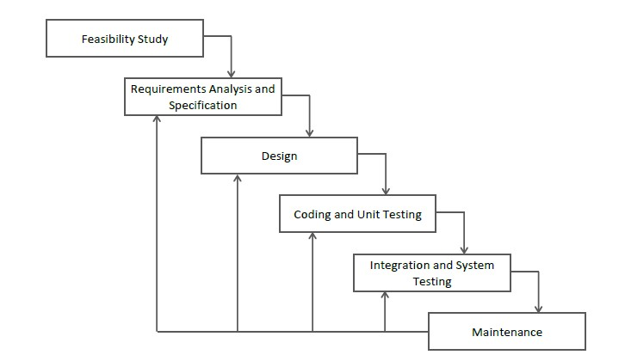

Figure 1: SLDC Waterfall Model

## 1.5 Project Modules

The entire project consists of 3 main modules, which are

* Admin Module
* Lawyer Module
* Client Module
* Team Member Module

### 1.5.1 Admin Module:

* Admin manages all lawyers.
* Admin verifies the lawyer whether he or she is legal or not.
* Admin can manage clients’ feedback.
* Admin can manage user queries.

### 1.5.2 Lawyer Module:

* Lawyers can accept or reject clients hiring requests.
* Lawyers can also register clients.
* Lawyers can manage case details.
* Lawyers can manage all appointments.
* Lawyers can manage clients' information
* Lawyers can add team members and assign them a task.

### 1.5.3 User (Client) Module:

* Client/User can hire a lawyer according to his/her choice.
* Client/User can see details of a hired lawyer.
* Client/User can contact hired lawyer.

### 1.5.4 Team Member Module:

* The team members can work on their assigned tasks and submit them.
* The team members can only see limited information provided by the lawyer.

# Chapter 2 Background

## 2.1 Background Research

Remember those times when you had to make phone calls to relatives or friends to find out the lawyers. When you had to hail a taxi by hand and rely on ads on walls to explore a better lawyer. When every single information has to be find physically. And also lawyer has to be hired physically by visiting the buildings or courts. That time was not a long time ago. Now a day the life style of the people is different. People feel uncomfortable and time consuming for going to court for hiring lawyer. So, online hiring saves a lot of time. Online hiring are usually available 24 hours a day and 7 days in a week. So it is very convenient for them to hire lawyer online. Technology has changed the law firm industry at an exponential rate in the last two decades.

An increasing amount of research has been conducted to understand the impacts of online finding lawyer development from the resident’s perspective. The driving force behind these phenomena can be attributed to the fact that the DLS has additionally played a vital role in social, cultural, and environmental impacts on people, destinations and Pakistan.

The main purpose of this Web App is to facilitate the clients to find lawyers online because customer cannot spend their precious time in markets trying to find out the best deal.

## 2.2 Existing Technology

Currently, several applications have been developed to address the issue of low technology consumption in law firms but some of the lawyers still shy away from using technology in their practice even though these applications have been tested and endorsed by the body of lawyers to improve the work efficiency and the profitability of the firm.

However, the attempts to incorporate technology in the legal sector have failed because of a few factors. Firstly, lawyers have been tagged pragmatists. This refers to them being able to see the positive effect of incorporating technology into their business as soon as possible. This is evident because word processing systems were quickly adapted to the law firms as compared to management applications because these lawyers saw immediate value in changing their current style. This is also very practical because lawyers have cut their cost through the use of technology by eradicating a lot of their employees.

## 2.3 Area of Study

Technology nowadays plays a significant role in our lives. From simple machines to complex one’s technology is used. This system is used by many lawyers in many cities to facilitate the users for online hiring them.

Law firm is one of the areas that can provide easiness in the community. For the purpose of promoting the DLS, the website must be accessible everywhere. A DLS website usually is a Lawyer to client, whose main target is the general public. Websites can support all the core activities of a law firm. Like manage appointments, adding cases, print clients’ data etc.

## 2.4 Reason of the Project

A Digital Lawyer Street website is a website that is dedicated to lawyers or advocates. The site may be focused on to provide easiness to user to find lawyers or advocates easily using internet. Hundreds of new cases are registered in different courts of Pakistan, our aim that people get appointment online. My main motive is to promote the use of technology in Pakistan. The purpose of this project is to provide the complete information about lawyer or advocate in single click. Our priority will be our user and their legal requirements. If the online lawyer finding industry emerge then the problem of rush in courts resolved too. Users will be able to find appropriate lawyer with affordable fees and related skill.

### 2.4.1 Accuracy of Information

The accuracy of information or measurements is their quality of being true or correct, even in small details. The information of data organization in information system can affect the speed, cost and of desired processing activities. Since all the calculation is done automatically, so the chances of error are very rare, which results in accuracy of system. The developed system provides powerful searching mechanism. This can even search a minor record in less than a second because the stored data in database is in accurate form due to validation checks. A computerized system’s accuracy is 100% while in manual it is on 40%.



Figure 2: Accuracy

### 2.4.2 Efficiency

The developed system is greater efficient than the older one. Wrong data entry is impossible as there are different checks that do not allowed to enter wrong data because of validations. The classification efficiency of the single-cycled classification model is intuitively worse than the multi-cycled model, as it requires more effort in collecting relatively comprehensive software measurement data to classify each unseen case. It is extremely important that software project managers determine which type of classification model is best suited to their specific objectives, since such a choice will significantly affect the accuracy and efficiency of the classification results.



Figure 3: Efficiency

### 2.4.3 Easy to Use

The source data input, review and modification can be repeated any number of times on computer graphics. The power system graphics generation should be easy and efficient. The web app is very easy to use and operate.



Figure 4: Easy to Use

### 2.4.4 Security

Application security means many different things to many different people. Security should be explicitly at the requirement level. Security methods are under the high level class and are considered to be an addition in to the original software. The habits formed from initial programming can be for a long time. Security is considered as a very critical issue for software systems. Software is itself a resource and thus must be afforded appropriate security. Software that is developed with security in mind is typically more resistant to both intentional attack and unintentional failures.

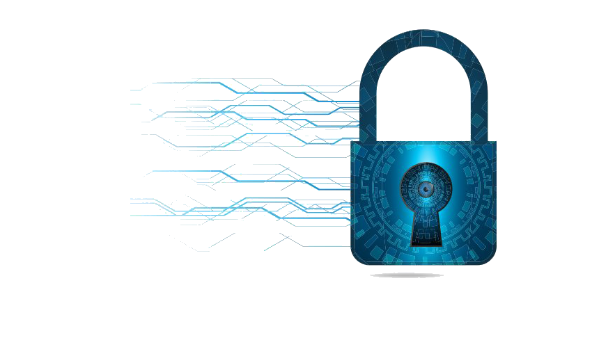

Figure 5: Security

### 2.4.5 User Friendly

Term user friendly refers to anything that makes it easier for novices to use a computer. Menu-driven programs, for example, are considered more user-friendly than command- driven systems. Online help systems are another feature of user-friendly programs.



Figure 6: User Friendly

### 2.4.6 Time Saving

Due to high speed of processing, the proposed system takes less time to access information from database and as it is online system so it is definitely time saving then going physically to office for lawyer hiring.



Figure 7: Time Saving

## 2.5 Objective of the project

In the attempt to appeal to lawyers to apply technology in their practice, the Digital Lawyer Street Software aims to increase the usage of cloud computing decreasing the need for staff to sit in a physical office, this also allows the access of files from anywhere in the world. The software also aims to improve the system such that it provides availability of online legal resources, the ability to consult documents while using the application. This Web based software allows the users to access the information wherever they are and this can be through different platforms like the phone, tablet and personal computers. The software also supports unlimited users as different law firms have a varied number of employees and clients. Finally, the system is suitable for the Pakistani environment in terms of the database values and the interfaces. Such a system is more responsive to clients as it does not only ease the law firms’ work but also that of the client. It also has a greater flexibility bearing in mind that it performs a range of tasks that would otherwise be done by a number of applications.

## 2.6 Methodology

The project consisted of the following components:

* This system provides the facility to customer to hire a lawyer according to his/her choice.
* This system is also providing the facility of viewing lawyers’ profiles.
* User may hire lawyer accordance to relative court.
* After hiring client can get appointment from lawyer.
* Admin can approve and disapprove lawyers after scrutiny.
* Admin can also control full website through admin panel like practice areas, services and testimonial.
* Admin can also give response on the queries of users.

# Chapter 3 System Requirement Analysis

## 3.1 System Functional Requirements

The requirement of system must be fulfilled for proper working of the system. Such requirements describe system behavior under specific conditions and include the product features and functions which web & app developers must add to the solution. Such requirements should be precise both for the development team and stakeholders.

### 3.1.1 Project Interactivity Plan

Website is user friendly due to third party control. User can save record and system is easy to use by user through user friendly GUI’s.

### 3.1.2 Signup Information

User must provide information in the form of First name, Last name, Email, Password and Confirm password then click on signup button to register him/her.

### 3.1.3 Login Information

User must provide username and password to login into the system. If admin want to delete the user, he/she can do it by clicking delete button in the user list visible.

### 3.1.4 Lawyer Record

Admin can delete and approve or view information of lawyer through admin panel.

**3.1.4.1 Add Lawyer**

Lawyer can be added by entering complete description data from keyboard into fields and clicking on register button. The following fields are required:

* + - * + First Name
        + Last Name
        + Education
        + Specialization
        + Experience
        + License Number
        + Law Firm Name
        + Email
        + Password
        + Phone Number
        + Address
        + Description
        + Upload Picture

**3.1.4.2 Update Record**

If the lawyer is going to update himself/herself following fields required:

* + - * + First Name
        + Last Name
        + Education
        + Experience
        + Law Firm
        + Password
        + Phone Number
        + Twitter
        + Facebook
        + instagram

**3.1.4.3 Delete Record**

If Admin wants to delete the user record, Admin can do it by clicking delete button.

* + - * + Lawyer ID

### 3.1.5 SRS Document (System Requirements Specification)

Table 1: Software Requirement Specification

|  |  |
| --- | --- |
| **Sr. No.** | **Description** |
| SRS-01 | System should be able to provide login facility |
| SRS-02 | System should be able to provide Sign Up facility |
| SRS-03 | System should be able to Register New Lawyer |
| SRS-04 | System should be able to Update Lawyer details |
| SRS-05 | System should be able to Delete Lawyer details |
| SRS-06 | System should be able to hire a client for lawyer |
| SRS-07 | System should be able to categorize lawyer based on specialization. |
| SRS-08 | System should be able to provide testimonial facility to users. |

## 3.2 Non-Functional Requirements of the system

The non-functional requirements elaborate a performance characteristic of a system. Non-functional requirements specify the quality of a system, is mostly related the satisfiability of the user.

* Ensure the privacy of customers.
* Exclude unauthorized access.
* Reliability
* Flexibility
* User Safety
* User Friendly
* Satisfiability of the user

## 3.3 Hardware & Software Requirements

### 3.3.1 Software Requirements

Table 2: Software Requirements

|  |  |
| --- | --- |
| Operating system | window 7/8/8.1/10/11 |
| Database | MySQLi |
| Web Browser | Google Chrome / Firefox / Opera Browser |
| Web page style sheet | HTML, CSS, Bootstrap, JavaScript, Ajax and JQuery |
| Program code | PHP, MySQLi |

### 3.3.2 Hardware Requirements

Table 3: Hardware Requirements

|  |  |
| --- | --- |
| Internet Require | Yes |
| Main Memory | Minimum 1GB |
| CPU speed | 2.6GHz |
| Monitor | EGA/SVGA (display),800X600 24 bits true color |
| Keyboard | Standard keyboard |
| Mouse | Standard Mouse / Touchpad |

## 3.4 Introduction of Tools

### 3.4.1 VS Code

Visual Studio Code is a shareware cross-platform source code editor with a Python application programming interface (API). It natively supports many programming languages and markup languages, and functions can be added by users with plugins, typically community- built and maintained under free-software licenses. Visual Studio Code can be downloaded and evaluated for free. There is no enforced time limit for the evaluation.



Figure 8: Visual Studio Code

### 3.4.2 HTML (Hyper Text Markup Language)

HTML is short for Hyper-Text Markup Language and is a language used to create electronic documents, especially pages on the World Wide Web that contains connections called hyperlinks to other pages.

HTML (Hypertext Markup Language) is the code that is used to structure a web page and its content. For example, content could be structured within a set of paragraphs, a list of bulleted points, or using images and data tables.



Figure 9: HTML (Hyper Text Markup Language)

### 3.4.3 CSS (Cascading Style Sheet)

CSS stands for Cascading Style Sheets. It describes how HTML elements are to be displayed on screen, paper, or in other media. CSS saves a lot of work. It can control the layout of multiple web pages all at once. External stylesheets are stored in CSS files. CSS is the language for describing the presentation of Web pages, including colors, layout, fonts and it allows one to adapt the presentation to different types of devices, such as large screens, small screens, or printers. CSS is independent of HTML and can be used with any XML-based markup language.



Figure 10: CSS (Cascading Style Sheet)

### 3.4.4 Bootstrap

Bootstrap is the most popular HTML, CSS, and JavaScript framework for developing responsive and mobile-first website. Bootstrap is a free collection of tools for creating websites and web applications. It contains HTML and CSS-based design templates for typography, forms, buttons, navigation and other interface components, as well as optional JavaScript extensions. Bootstrap is a framework to help you design websites faster and easier. It includes HTML and CSS based design templates for typography, forms, Buttons, tables, navigation, modals, image carousels, etc. Here are some additional reasons to use Bootstrap: Bootstrap's responsive CSS adjusts to phones, tablets, and desktops.

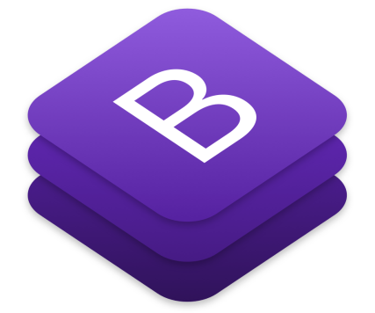

Figure 11: Bootstrap

### 3.4.5 JavaScript

JavaScript is a text-based programming language used both on the client-side and server- side that allows you to make web pages interactive. Where HTML and CSS are languages that give structure and style to web pages, JavaScript gives web pages interactive elements that engage a user. JavaScript can calculate, manipulate and validate data.



Figure 12: JavaScript

### 3.4.6 JQuery

JQuery is a JavaScript Library. It greatly simplifies JavaScript programming. JQuery is a fast, small, and feature-rich JavaScript library. It makes things like HTML document traversal and manipulation, event handling, animation, and Ajax much simpler with an easy-to-use API that works across a multitude of browsers. (jquery.com).The purpose of jQuery is to make it much easier to use JavaScript on your website. JQuery takes a lot of common tasks that require many lines of JavaScript code to accomplish, and wraps them into methods that you can call with a single line of code.



Figure 13: jQuery

### 3.4.7 PHP

PHP is a server scripting language, and a powerful tool for making dynamic and interactive Web pages. PHP is a widely-used, free, and efficient alternative to competitors such as Microsoft's ASP. PHP is a server-side scripting language that is used to develop Static websites or Dynamic websites or Web applications. PHP stands for Hypertext Pre- processor, that earlier stood for Personal Home Pages. PHP scripts can only be interpreted on a server that has PHP installed.



Figure 14: PHP

### 3.4.8 AJAX

Update a web page without reloading the page. Ajax Request data from a server - after the page has loaded. It receives data from a server - after the page has loaded. It sends data to a server - in the background.



Figure 15: AJAX

### 3.4.9 MySQL

* + - * + MySQL is a freely available open-source Relational Database Management System (RDBMS) that uses Structured Query Language (SQL). SQL is the most popular language for adding, accessing and managing content in a database. It is most noted for its quick processing, proven reliability, ease and flexibility of use

1.15.10 Server-Side Programming: PHP will be used as server side programming. The 'i' in **MySQLi** stands for Improved. Therefore, this is also known as the improved version of MySQL.

* + - * + MySQLi is an open-source relational database management system (RDBMS) in July 2013, it was the world's second most widely used RDBMS, and the most widely used open-source client–server RDBMS.
        + Basically, MySQL is the old database driver, and MySQLi is the improved driver. MySQLi can be done procedural and object-oriented whereas MySQL can only be used procedurally. MySQLi, also supports prepared statements which protect from SQL Injection.



Figure 16: MySQL

# Chapter 4 System Design

## 4.1 Use case – fully dressed

A use case is a description of a system’s behavior from a user’s standpoint. For system developers, this is a valuable tool: requirements from a user’s point of view. Use case diagrams are used to gather the requirements of a system including internal and external influences. These requirements are mostly design requirements. Hence, when a system is analyzed to gather its functionalities, use cases are prepared and actors are identified.

### 4.1.1 Importance of Use Case Diagrams

As mentioned before use case diagrams are used to gather a usage requirement of a system. Depending on your requirement you can use that data in different ways. Below are few ways to use them.

* + - * **To identify functions and how roles interact with them** – The primary purpose of use case diagrams.
      * **For a high-level view of the system** – Especially useful when presenting to managers or stakeholders. You can highlight the roles that interact with the system and the functionality provided by the system without going deep into inner workings of the system.
      * **To identify internal and external factors** – This might sound simple but in large complex projects a system can be identified as an external role in another use case.

### 4.1.2 Use Case Diagram objects

Use case diagrams consist of 4 objects.

* + - * Actor
      * Use case
      * System
      * Package

**4.1.2.1 Actor**

Actor in a UML Use Case Diagram is any entity (person, organization or external system) that performs a role in one given system. In a use case diagram, an actor interacts with a use case.



Figure 17: Actor

**4.1.2.2 Use case**

A use case in a UML Use Case Diagram gives a visual representation of distinct business functionalities in a system.



Figure 18: Use Case

**4.1.2.3 System**

A system in a UML Use Case Diagram is a rectangle spanning all the use cases in the system that defines the scope of your system. Anything within the box represents functionality that is in scope and anything outside is not. Note that the actors in the system are outside the system.



Figure 19: System

**4.1.2.4 Package**

A package object in a UML Class and Use Case Diagram provides the ability to group together classes and/or interfaces that are either similar in nature or related. Grouping these design elements in a package element provides for better readability of UML diagrams, especially complex diagrams.

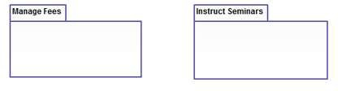

Figure 20: Package

**4.1.2.5 Relationship**

Relationship is an association between use case and actor.

There are several Use Case relationships:

* Association
* Extend
* Generalization
* Include

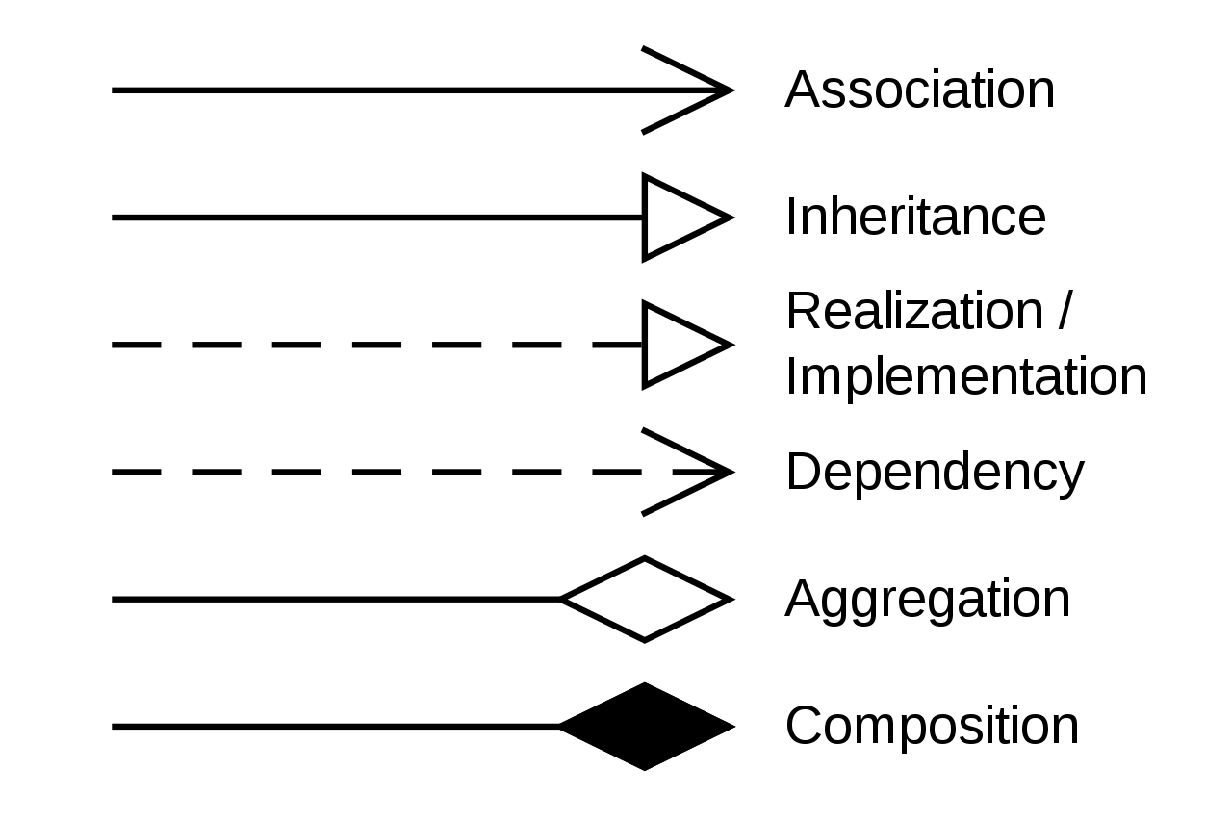

Figure 21: Relationships

### 4.1.3 Use Case Diagram

In the rare case you are performing the use case analysis of some authentication or user management software, such as an SSO solution, in which the business value for the user is really to get logged into some protected systems and perform activities.

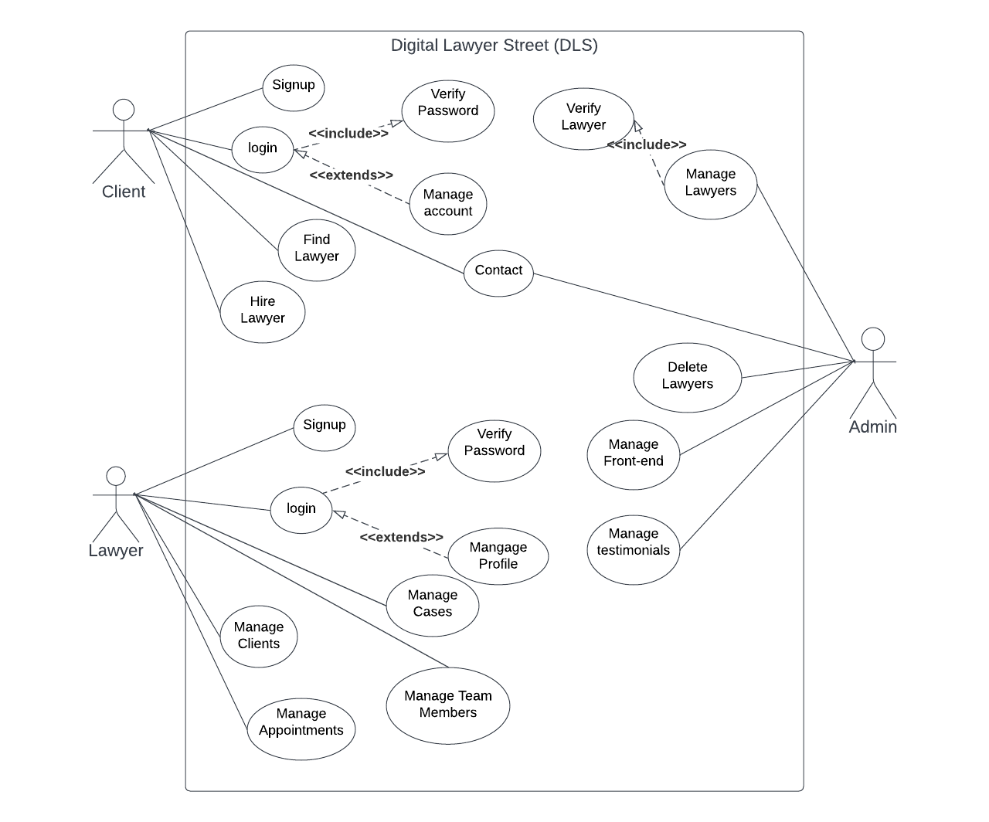

Figure 22: Use Case Diagram

**Pre-Conditions**

* + - * + User must be logged in in order to hire lawyer.
        + However, any user can find lawyer even without login.

**Primary Scenario**

* User will open the lawyer menu item from the main Menu.
* User will click on the desired lawyer profile or view profile button to view lawyer details.
* The information about the specific lawyer is loaded.
* User can check different lawyers’ details as same process.
* User can hire lawyer.
* User can contact with hired lawyer on any media platform

**Secondary Scenario**

* User can cancel the hiring request at any time.

**Post Condition**

* The user can fix appointment with lawyer now.

## 4.2 WBS fully dressed

* + - Work breakdown structure allows you to decompose project into small manageable sections, also known as deliverables. Clearly defined deliverables are easy to assign, allow you to accurately estimate needed time and resources and track their completion.
    - Work breakdown structure (WBS) in project management is a method for completing a complex, multi-step **project**. It's a way to divide and conquer large projects to get things done faster and more efficiently. The goal of a WBS is to make a large project more manageable.

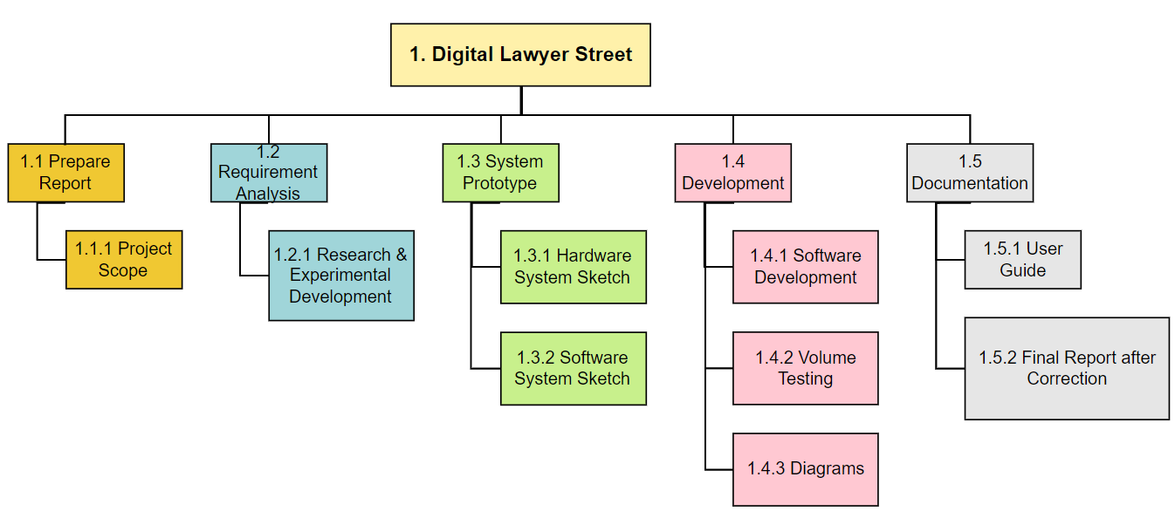

Figure 23: WBS (Work Breakdown Structure)

## 4.3 System Sequence diagram

* + - Sequence Diagrams are interaction diagrams that detail how operations are carried out. They capture the interaction between objects in the context of collaboration.
    - Sequence Diagrams are time focus and they show the order of the interaction visually by using the vertical axis of the diagram to represent time what messages are sent and when.
    - A sequence diagram simply depicts interaction between objects in a sequential order i.e. the order in which these interactions take place. We can also use the terms event diagrams or event scenarios to refer to a sequence diagram.
    - Sequence diagrams describe how and in what order the objects in a system function.

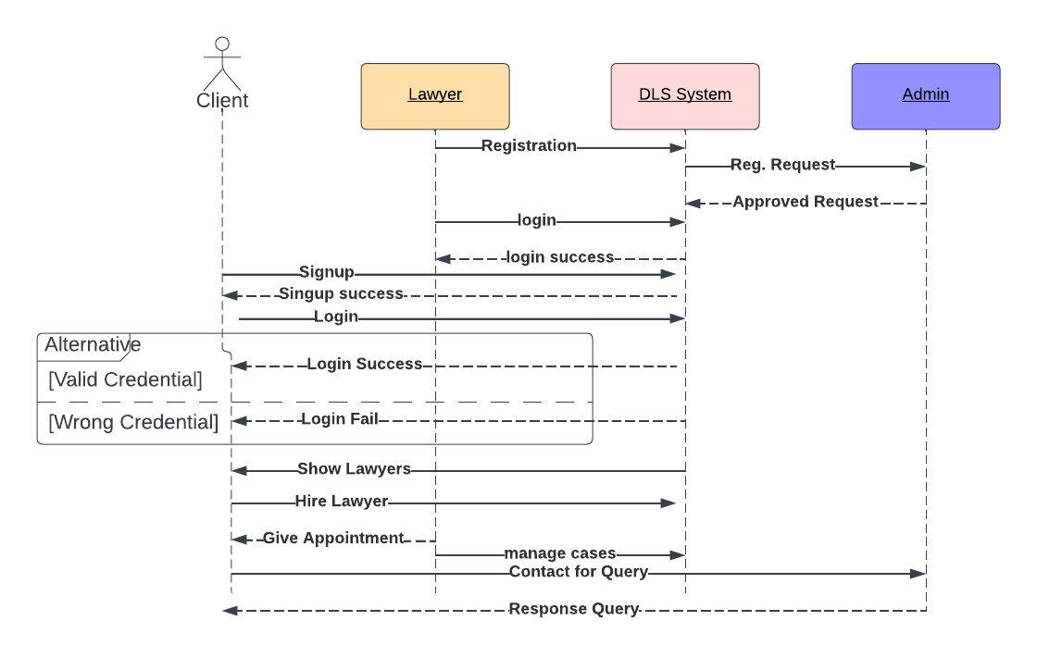

Figure 24: Sequence Diagram

## 4.4 Class diagram

* + - A class diagram in the Unified Modeling Language (UML) is a type of static structure diagram that describes the structure of a system by showing the system's classes, their attributes, operations (or methods), and the relationships among objects.
    - The class diagrams are widely used in the modeling of object oriented systems because they are the only UML diagrams, which can be mapped directly with object-oriented languages. Class diagram shows a collection of classes, interfaces, associations, collaborations, and constraints.
    - Class diagrams are the best way to illustrate a system's structure in a detailed way, showing its attributes, operations as well as its inter-relationships.

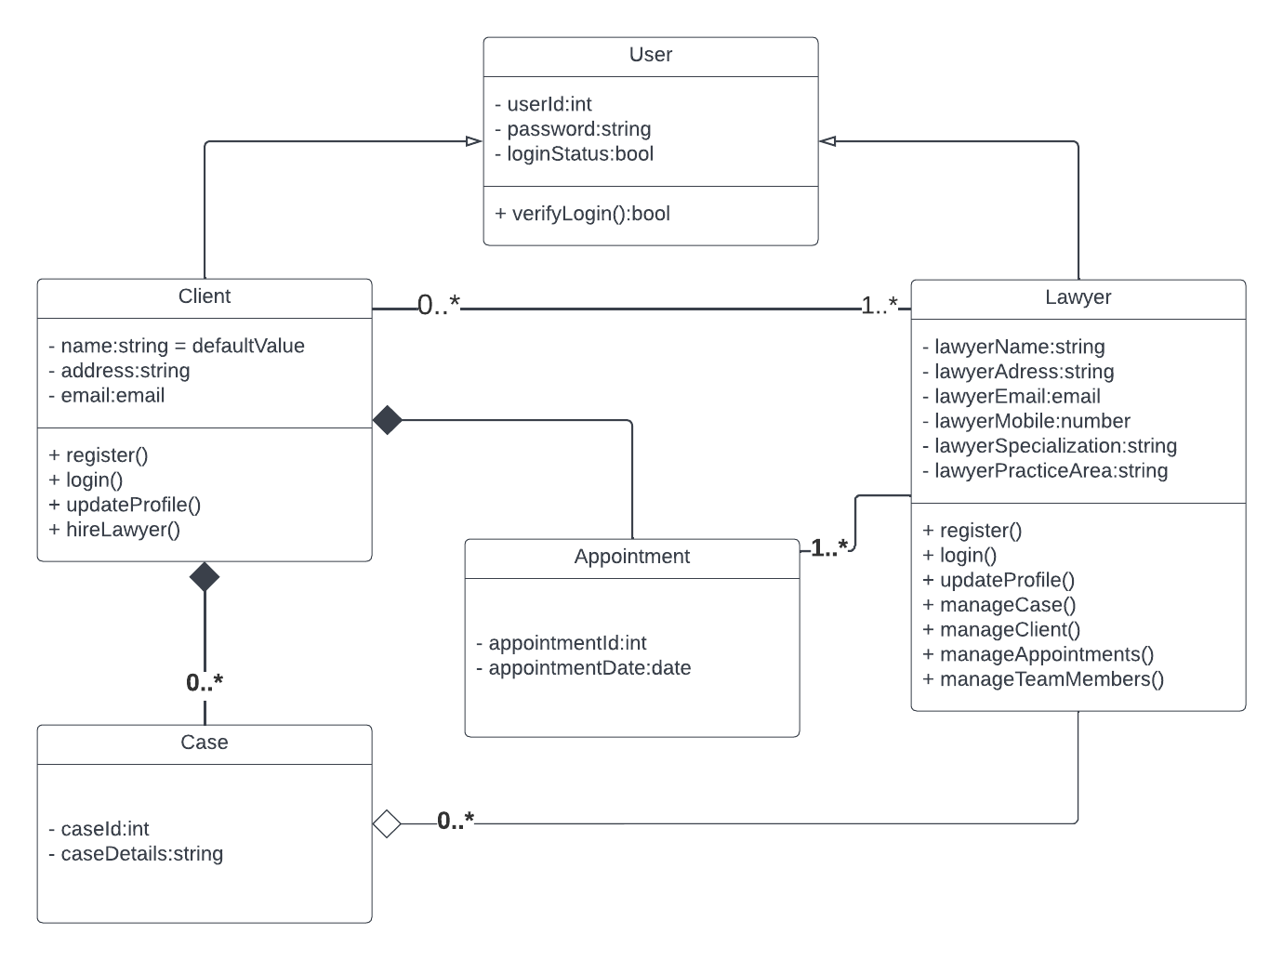

Figure 25: Class Diagram

## 4.5 ER (Entity Relationship Model) Model

* + - **Entity Relationship Model** (ER Modeling) is a graphical approach to database design. It is a high-level data model that defines data elements and their relationship for a specified software system. An ER model is used to represent real-world objects. An Entity is a thing or object in real world that is distinguishable from surrounding environment.
    - The three main components of the ER Model are entities, attribute and relationship. In ERM terms, an entity is a "thing" within the organization that we want to keep information about, such as a customer, employee or course.

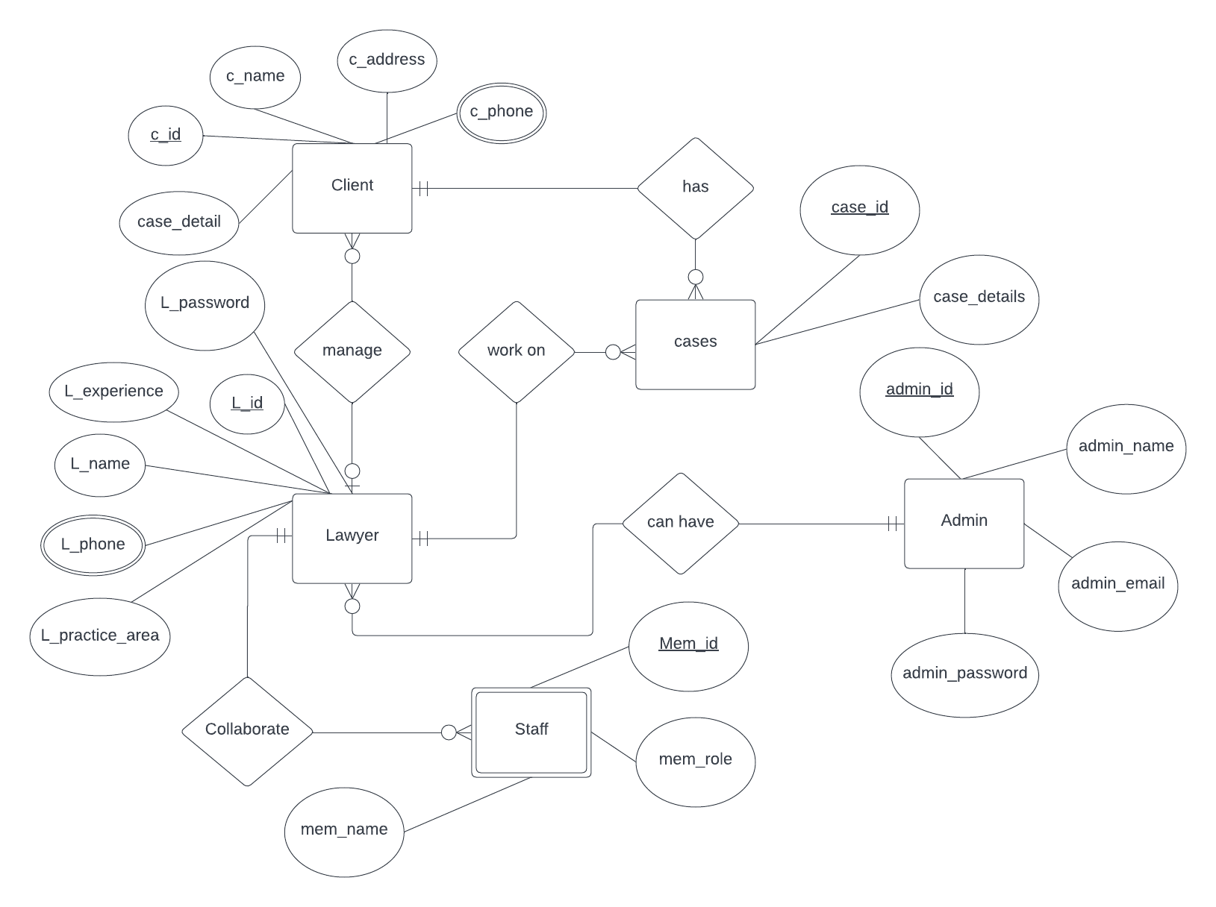

Figure 26: ER (Entity Relationship Diagram)

### 4.6 Data Flow Diagram

* + - Data flow diagrams are used to graphically represent the flow of data in a business information system. DFD describes the processes that are involved in a system to transfer data from the input to the file storage and reports generation. Data flow diagrams can be divided into logical and physical.
    - There are two types of DFD:

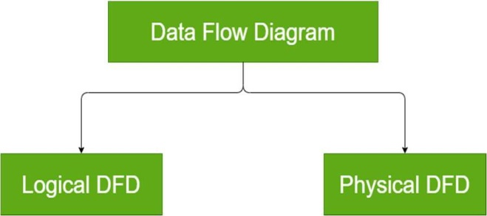

Figure 27: DFD Types

### 4.6.1 Symbols and Notations Used in DFDs

Two common systems of symbols are named after their creators:

* + - * Yourdon and Coad
      * Yourdon and DeMarco
      * Gane and Sarson

### 4.6.2 Data Flow Diagram of Digital Lawyer Street (DLS)

**Context level DFD – 0 Level DFD**

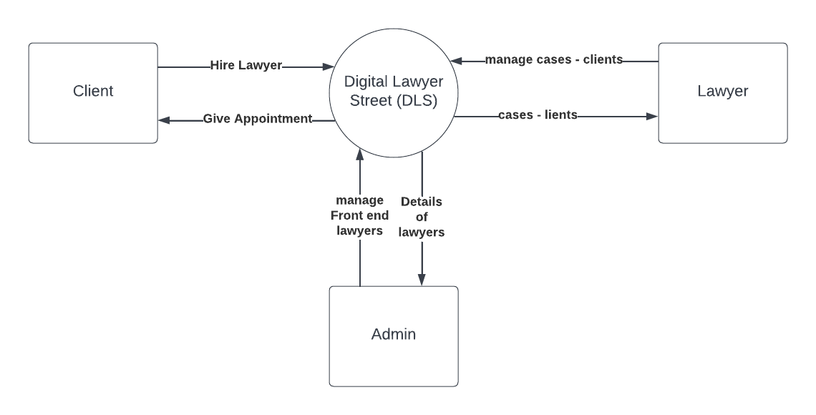

Figure 28: Context Level DFD

**LEVEL 1 DFD**

Level 1 DFD contains more details than level 0 DFD but less information than Level 2 DFD. It describes the flow in deeper manner.

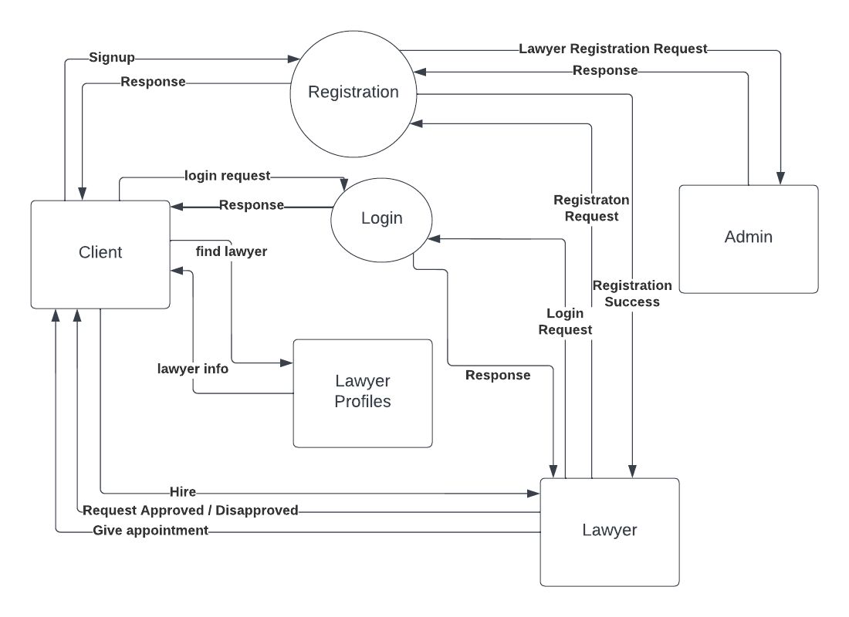

Figure 29: Level 1 DFD

**LEVEL 2 DFD**

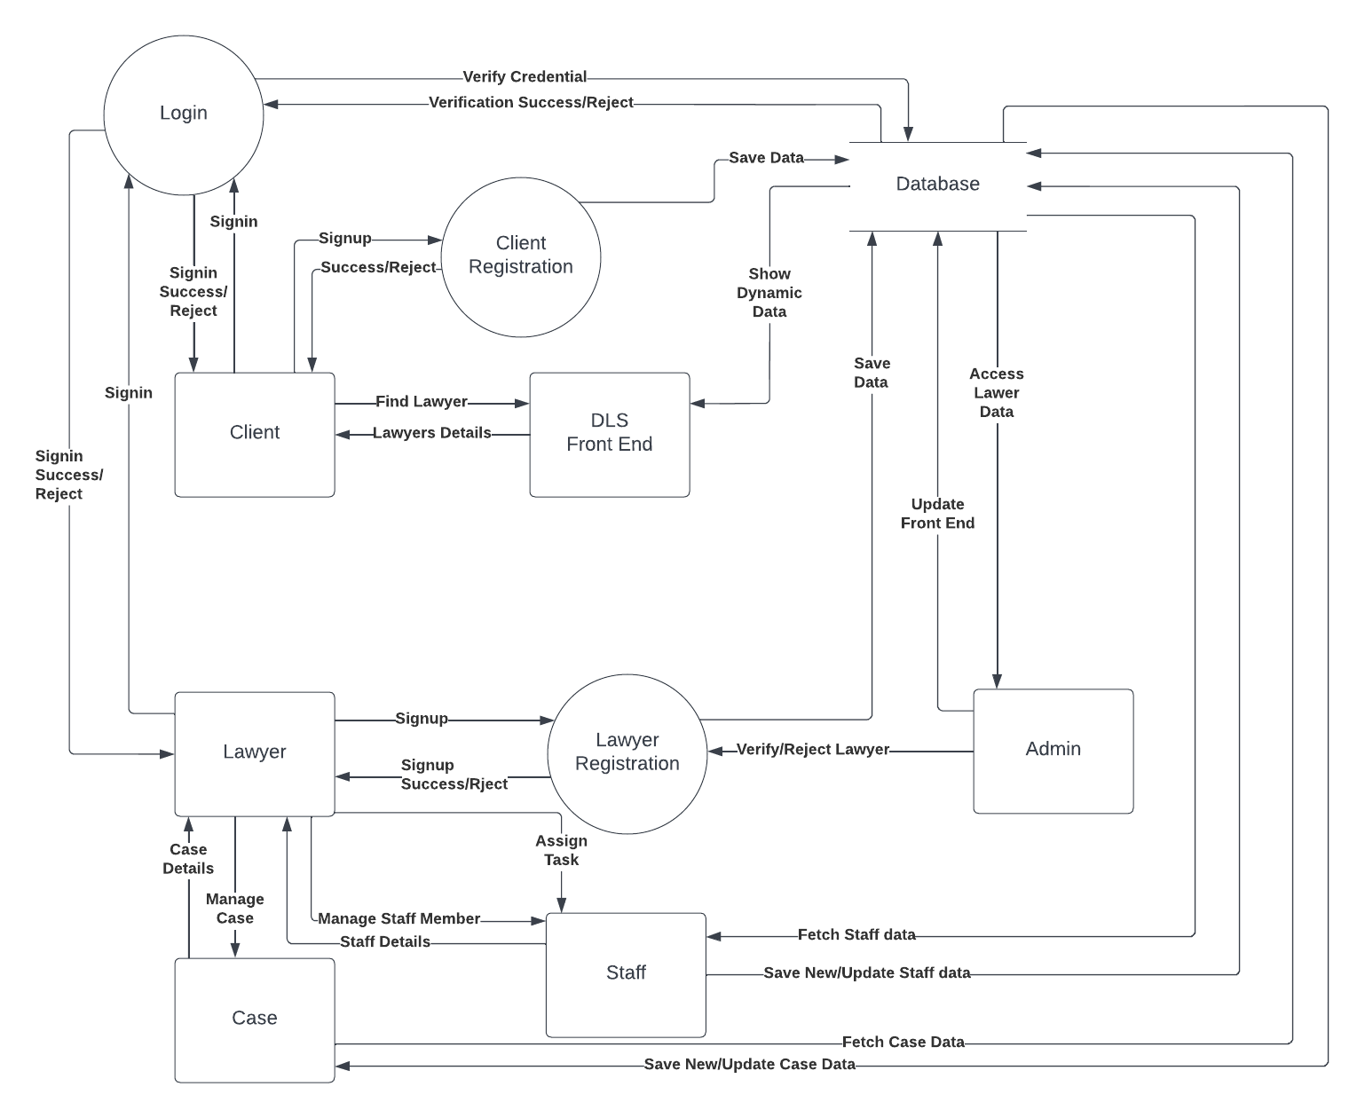

Figure 30: Level 2 DFD

# Chapter 5 Testing & Implementation

## 5.1 Testing Methods

System Testing methods are the various strategies or approaches used to test an application to ensure that it behave and looks as expected. These encompass everything from front to backend testing, including unit and system testing.

## 5.2 Functional vs. non-functional testing

The goal of utilizing numerous testing methodologies in your development process is to make sure your software can successfully operate in multiple environments and across different platforms. These can typically be broken down between functional and non- functional testing. Functional testing involves testing the application against the business requirements. It incorporates all test types designed to guarantee each part of a piece of software behaves as expected by using uses cases provided by the design team or business analyst. These testing methods are usually conducted in order and include:

* + - Unit testing
    - Integration testing
    - System testing
    - Acceptance testing

Non-functional testing methods incorporate all test types focused on the operational aspects of a piece of software. These include:

* + - Performance testing
    - Security testing
    - Usability testing
    - Compatibility testing

The key to releasing high quality software that can be easily adopted by your end users is to build a robust testing framework that implements both functional and non-functional software testing methodologies.

### 5.2.1 Functional Testing

Functional Testing consists of following testing techniques.

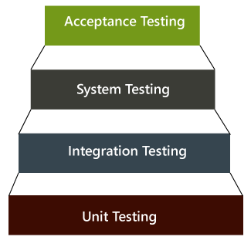

Figure 31: Functional Testing

**Unit Testing**

Unit testing is the first level of testing and is often performed by the developers themselves. It is the process of ensuring individual components of a piece of software at the code level are functional and work as they were designed to. Unit testing can be conducted manually, but automating the process will speed up delivery cycles and expand test coverage.

Developers in a test-driven environment will typically write and run the tests prior to the software or feature being passed over to the test team. Unit testing can be conducted manually, but automating the process will speed up delivery cycles and expand test coverage.

Unit testing will also make debugging easier because finding issues earlier means they take less time to fix than if they were discovered later in the testing process Test Left is a tool that allows advanced testers and developers to shift left with the fastest test automation tool embedded in any IDE.

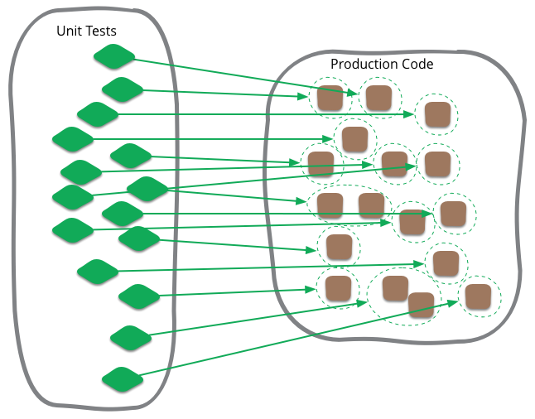

Figure 32: Unit Testing

**Integration Testing**

After each unit is thoroughly tested, it is integrated with other units to create modules or components that are designed to perform specific tasks or activities. These are then tested as group through integration testing to ensure whole segments of an application behave as expected (the interactions between units are seamless). These tests are often framed by user Scenarios, such as logging into an application or opening files. Integrated tests can be conducted by either developers or independent testers and are usually comprised of a combination of automated functional and manual tests.

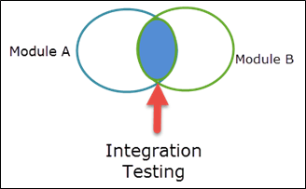

Figure 33: Integration Testing

**System Testing**

System testing is a black box testing method used to evaluate the completed and integrated system, as a whole, to ensure it meets specified requirements. The functionality of the software is tested from end-to-end and is typically conducted by a separate testing team than the development team before the product is pushed into production.

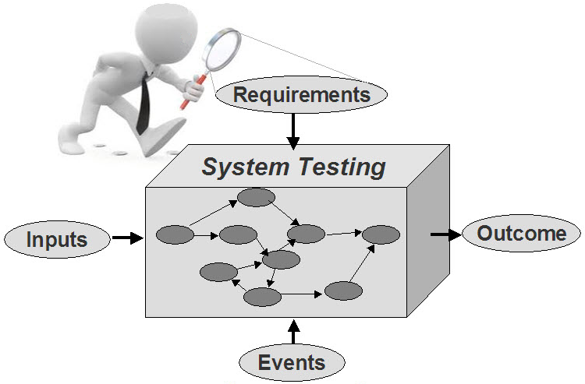

Figure 34: System Testing

**Acceptance Testing**

Acceptance testing is the last phase of functional testing and is used to assess whether or final piece of software is ready for delivery. This requires the product be tested both internally and externally, meaning you’ll need to get it into the hands of your end users for beta testing along with those of your QA team. **Acceptance tests** are carried out upon reception of new devices or equipment. The **purpose of acceptance testing** is to verify that the correct devices have been delivered according to the contract conditions and technical specifications, and in some cases, whether the equipment is properly installed. This requires the product be tested both internally and externally, meaning you’ll need to get it into the hands of your end users for beta testing along with those of your QA team.

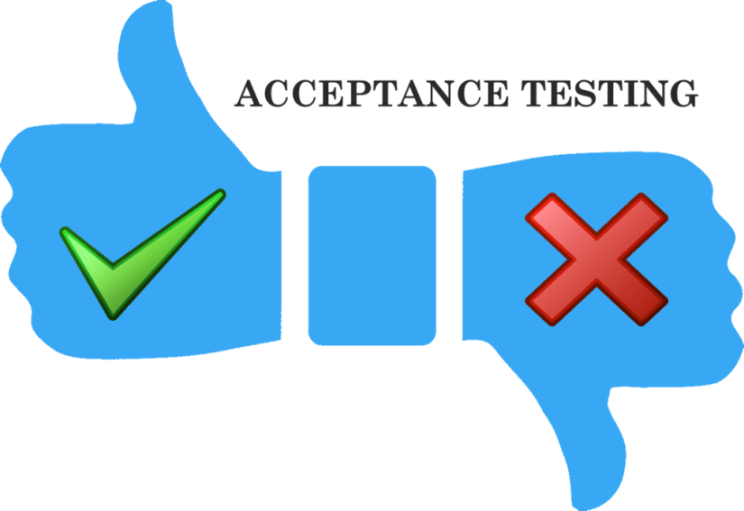

Figure 35: Acceptance Testing

### 5.2.2 Non- functional Testing

Performance testing is a non-functional testing technique used to determine how an application will behave under various conditions. The goal is to test its responsiveness and stability in real user situations. It is designed to test the readiness of a system as per non- functional parameters which are never addressed by functional testing. An excellent example of non-functional test would be to check how many people can simultaneously login into software. The goal is to test its responsiveness and stability in real user situations. Performance testing can be broken down into four types:

#### Load testing

Load testing is the process of putting increasing amounts of simulated demand on your software, application, or website to verify whether or not it can handle what it’s designed to handle. When the load is increased beyond normal usage patterns, in order to **test** the system's performance at exceptionally high or peak loads, it is known as stress testing. Load testing is performed to find out the upper limit of the system or application.

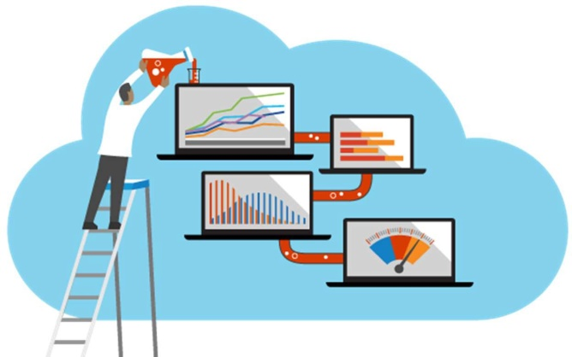

Figure 36: Load Testing

#### Stress testing

Stress testing takes this a step further and is used to gauge how your software will respond at or beyond its peak load. The goal of stress testing is to overload the application on purpose until it breaks by applying both realistic and unrealistic load scenarios. With stress testing, you’ll be able to find the failure point of your piece of software. **Stress testing** refers to a type of **testing** that is so harsh, it is expected to push the program to failure.



Figure 37: Stress Testing

#### Endurance testing

Endurance testing**,** also known as soak testing, is used to analyze the behavior of an application under a specific amount of simulated load over longer amounts of time. The goal is to understand how your system will behave under sustained use, making it a longer process than load or stress testing (which are designed to end after a few hours). A critical piece of endurance testing is that it helps uncover memory leaks.

#### Spike testing

Spike testing is a type of load test used to determine how your software will respond to substantially larger bursts of concurrent user or system activity over varying amounts of time. The goal is to purposefully find loopholes and security risks in the system that could result in unauthorized access to or the loss of information by probing the application for weaknesses. There are multiple types of this testing method, each of which aimed at verifying six basic principles of security:

* + - * + Integrity
        + Confidentiality
        + Authentication
        + Authorization
        + Availability
        + Non-repudiation

#### Usability testing

Usability testing is a testing method that measures an application’s ease-of-use from the end-user perspective and is often performed during the system or acceptance testing stages. The goal is to determine whether or not the visible design and aesthetics of an application meet the intended workflow for various processes, such as logging into an application.

#### Compatibility testing

Compatibility testing is used to gauge how an application or piece of software will work in different environments. It is used to check that your product is compatible with multiple operating systems, platforms, browsers, or resolution configurations. The goal is to ensure that your software’s functionality is consistently supported across any environment you expect your end users to be using.

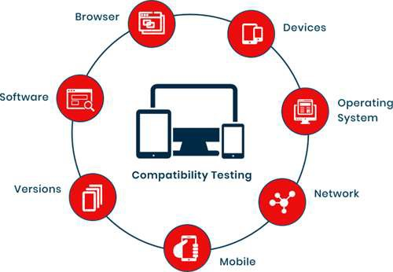

Figure 38: Compatibility Testing

## 5.3 Test Cases

A test case is the set of steps that need to be done in order to test a specific function of the software. They are developed for various scenarios so that testers can determine whether the software is working the way it should and producing the expected results.

#### 5.3.1 Data and Database Integrity Testing

Table 4: Data Integrity

|  |  |  |
| --- | --- | --- |
| **Test Objectives** | Our main objective of this is to ensure that the tables we created rightly Objective accessed from the user interfaces and rightly updated, modified and deleted data from the tables | |
| **Test Cases** | **Test Case Description** | **Result** |
| Provide login information | Data entered Successfully |
| Select a specific task and complete it | Task has been completed |
| Add all queries related to lawyers, cancellation and confirmation of lawyer | All data has successfully entered |
| **Completion Criteria** | All tables that created are successfully accessed from the user interfaces and successfully updated, modified and deleted. | |
| **Special** | MYSQL server is uses as DBMS | |

### 5.3.2 Function testing

Table 5: Function Testing

|  |  |  |
| --- | --- | --- |
| **Test Objectives** | Our main objective of this is to test functions that are on a services provider/user/admin interface that fulfilling their functionality data entry, and retrieval. | |
| **Test Cases** | **Test Case Description** | **Result** |
| Check all buttons that helps user to navigate from one their functions. Page to another. | All the buttons successfully performed their functions. |
| Check login | Valid person successfully logged in. |
| All data entry operations can be checked by entering data. | All data entry operations successfully performed their functionalities. |
| Check another function. | All other functions performed their functionalities. |
| Completion | All functions successfully performed their functionalities. | |

#### 5.3.3 User interface Testing

Table 6: User Interface Testing

|  |  |  |
| --- | --- | --- |
| **Test Objective** | Our main objective of this to do check navigation including window to window, field to field, and use of access methods e.g. focus on other characteristics like size, position, state, colors and any other characteristics | |
| **Test Cases** | **Test Case Description** | **Result** |
| Every service provider like admin and user.  Interface can be checked one by one. | All characteristics that are mentioned above are fulfill |
| **Completion Criteria** | Tab key, esc key work properly. Mouse movement is ok. Colors are professional and text color is ok.  Text is easily readable and navigation among pages is ok. | |
| **Special Consideration** | Attractive interface | |

### 5.3.4 Performance Testing

***Table 5.4:*** Performance Testing

|  |  |  |
| --- | --- | --- |
| **Test Objectives** | Main goal of this is that when admin add, modify and delete data and place a new data the response showed in a proper time or not.  What happened when a lot of data entered at the same time to server? | |
| **Test Cases** | **Test case Description** | **Result** |
| When a lot number of request come from Application. | This application has its own server so all these requests should be fulfilled in proper time. |
| When admin enter, delete or modify any entity. | Database server respond quickly |
| **Criteria** | There is no restriction for data. Data can be easily modified. | |
| **Special** | The database server should have capability to respond at proper time duration. | |

# Chapter 6 User Manual

## 6.1 Main/Home view

A home page is the main web page of a website. The term also refers to one or more pages always shown in a web browser, when the application starts up. In this way it is also known as start page.



Figure 39: Home Screen

## 6.2 Our Lawyers Page

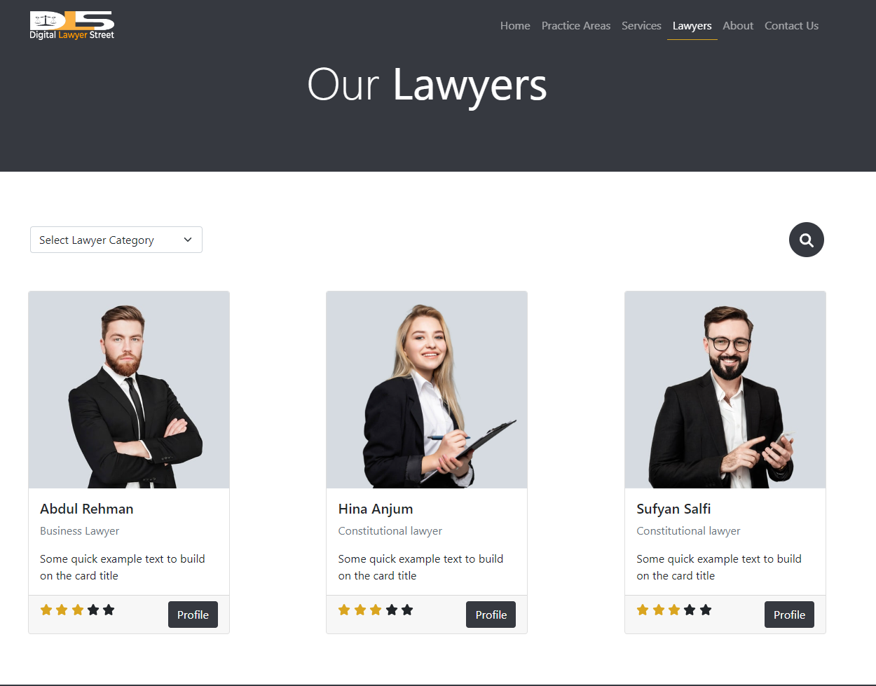

Figure 40: Lawyers Page

## 6.3 Services Page

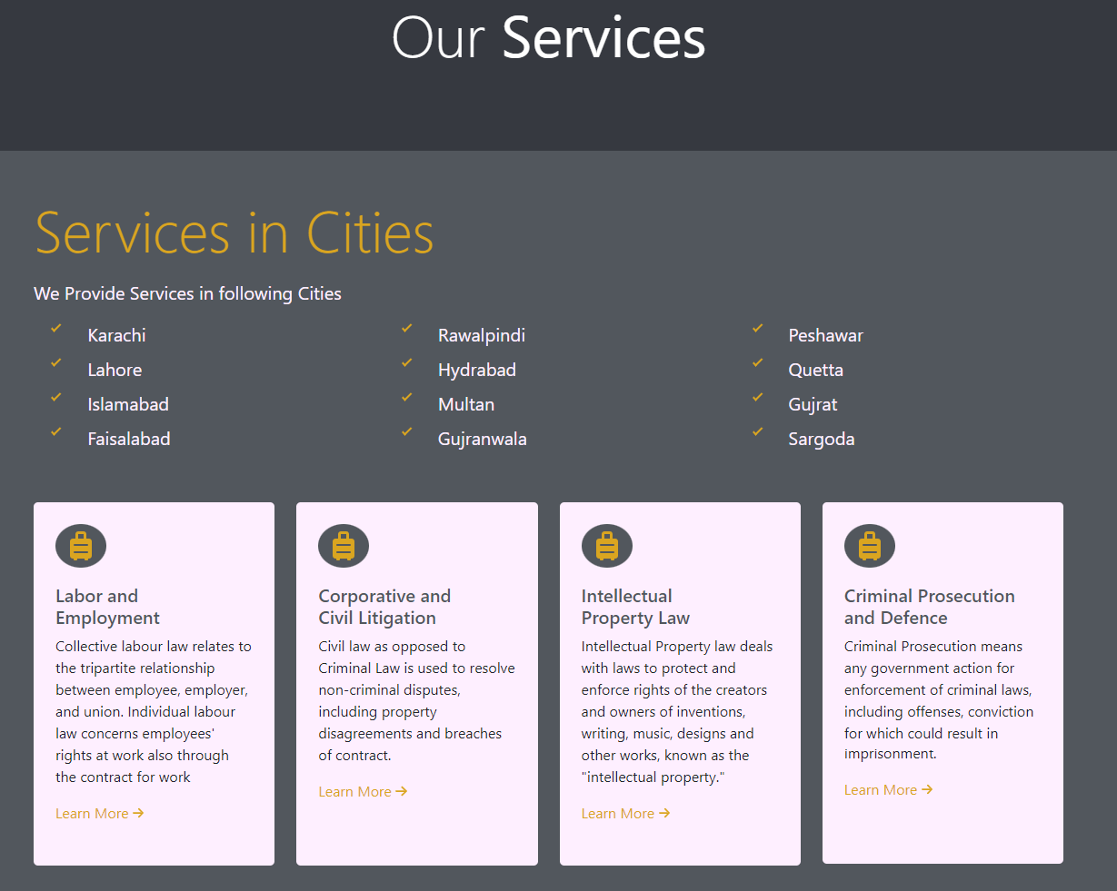

Figure 41: Services

## 6.4 Testimonial Page

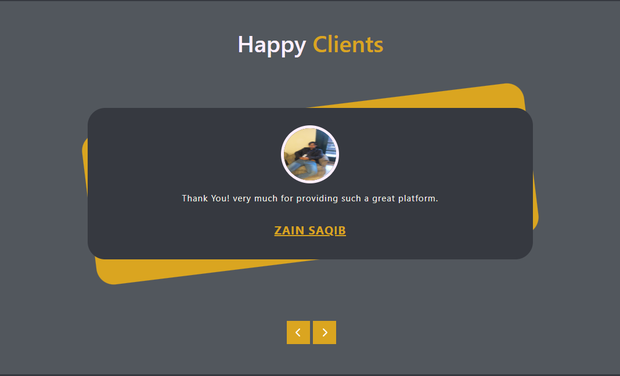

Figure 42: Testimonials

## 6.5 About Us Page



Figure 43: About Us

## 6.6 Contact Us Page

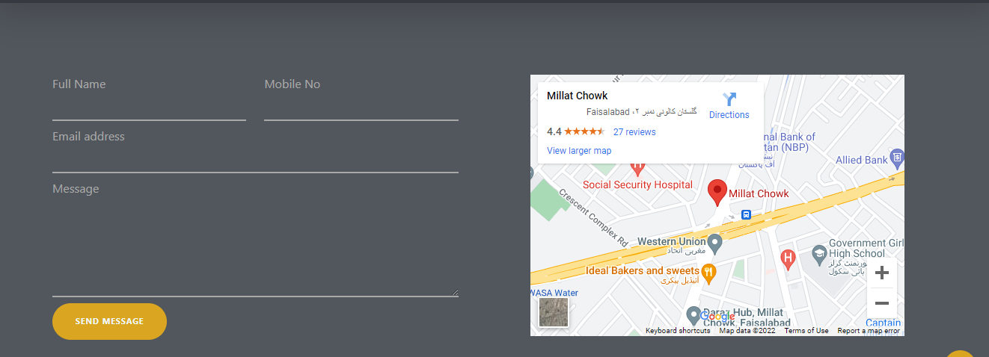

Figure 44: Contact Us

## 6.7 Footer

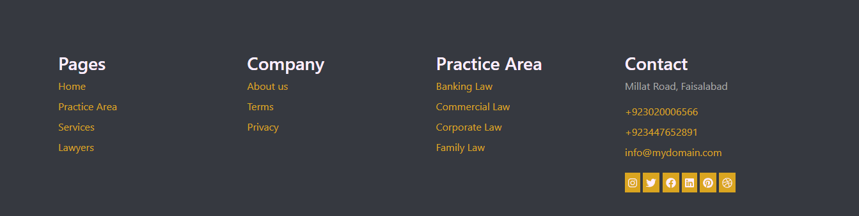

Figure 45: Footer

## 6.8 DLS Statistics

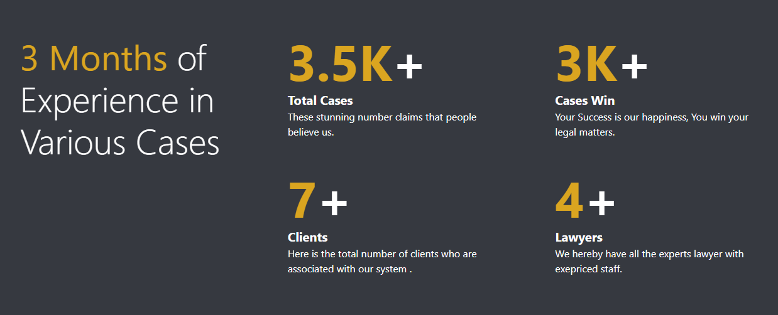

Figure 46: DLS Statistics

## 6.9 Forget Password

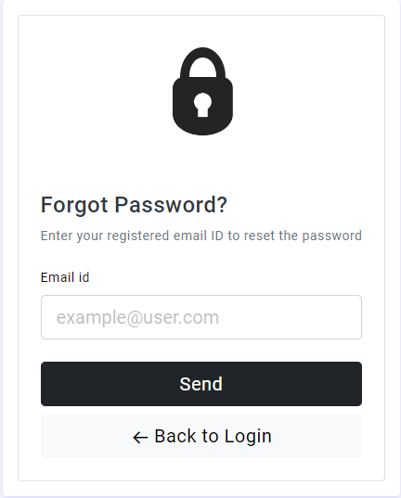

Figure 47: Forget Password

## 6.10 Lawyer Registration Page

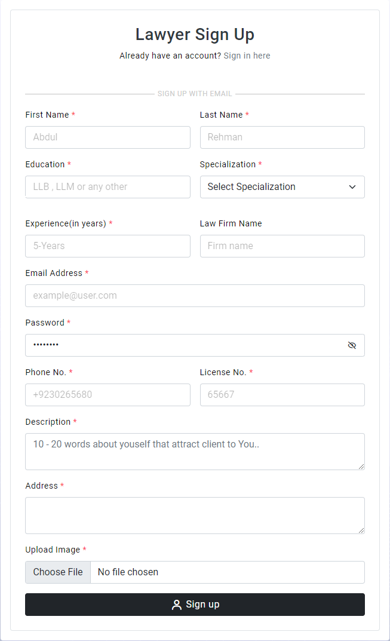

Figure 48: Lawyer Registration

## 6.11 User Login

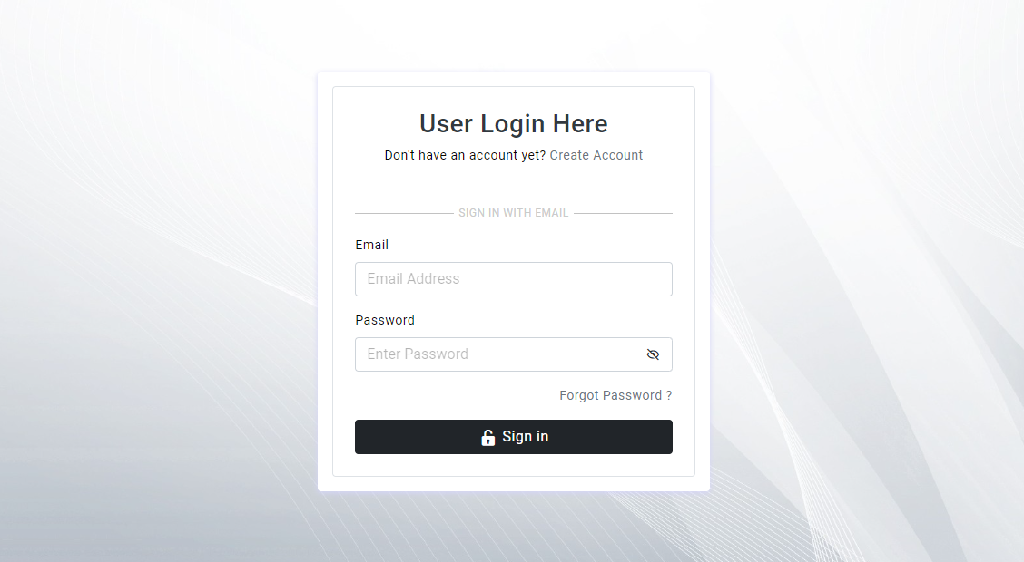

Figure 49: Login Area

## 6.12 User Dashboard

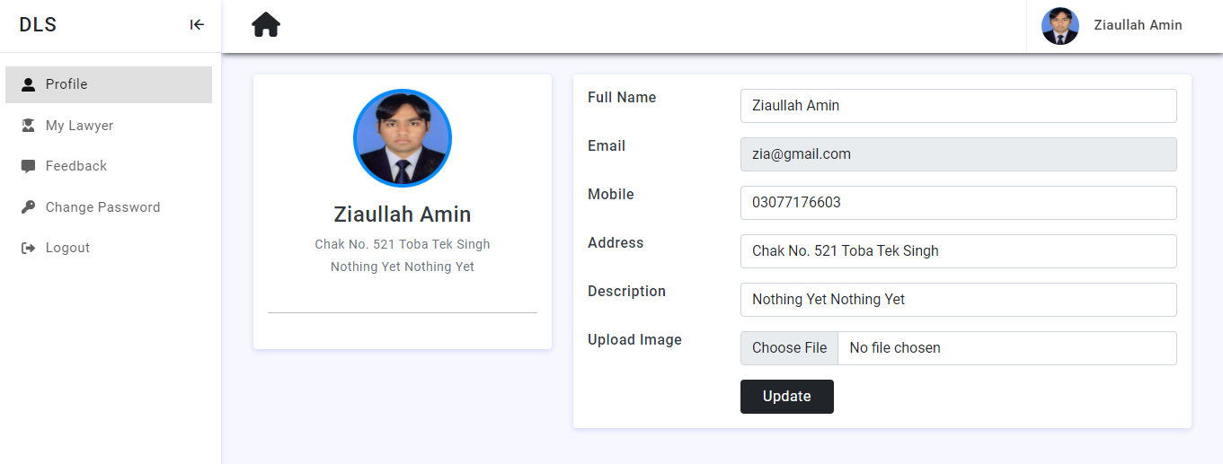

Figure 50: User Dashboard

## 6.13 Lawyer Dashboard

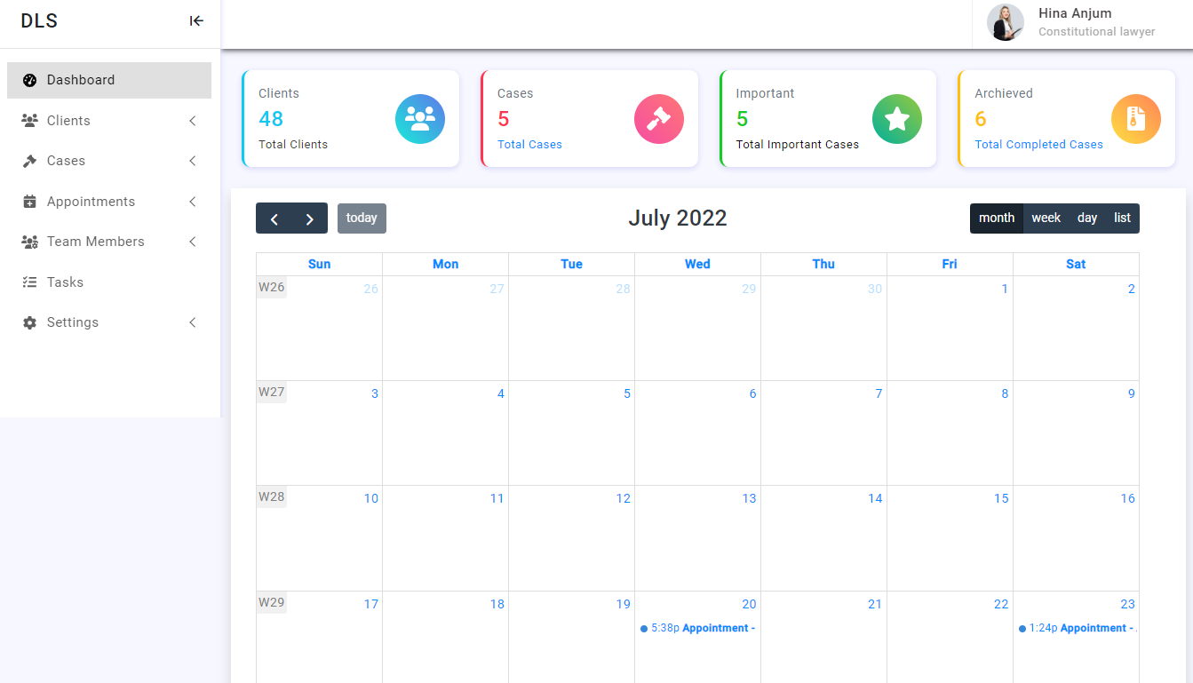

Figure 51: Lawyer Dashboard

## 6.14 Lawyer Requests

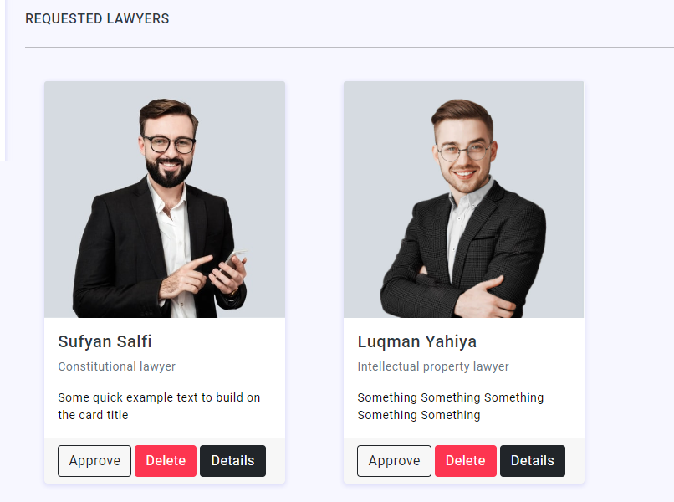

## 6.15 List of Lawyers

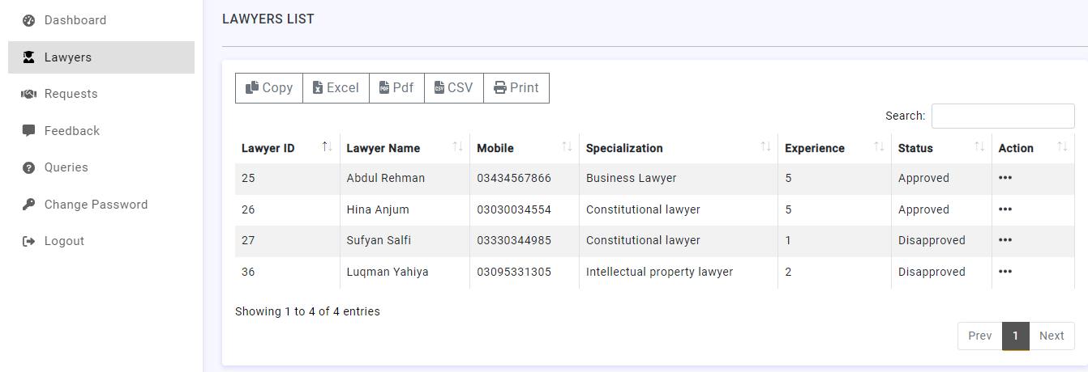

Figure 52: Lawyer List

## 6.16 Database Connection

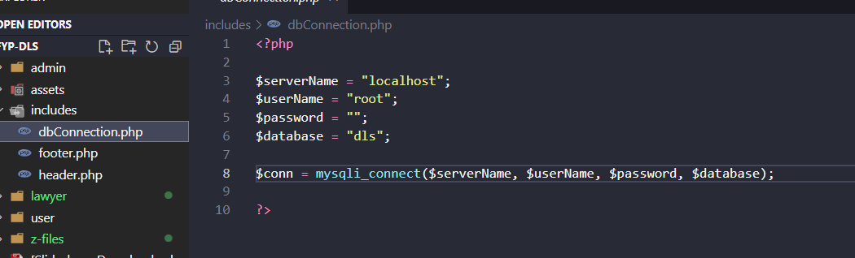

Figure 53: Database Connection

## 6.17 Front End Coding

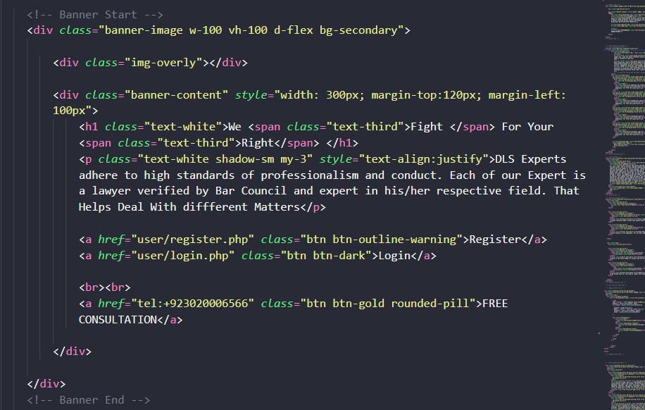

Figure 54: Front End

## 6.18 Backend Coding

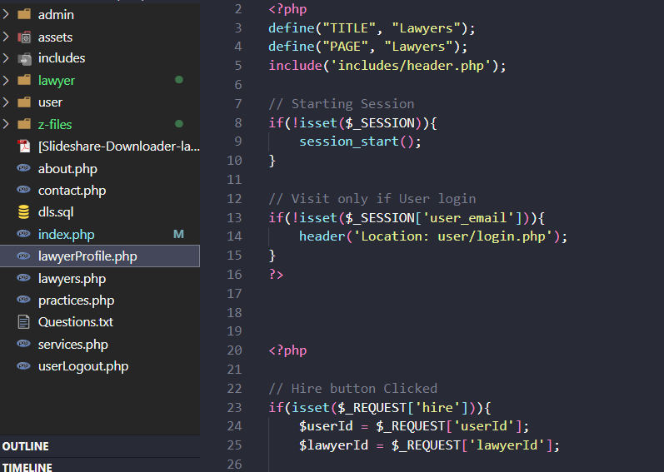

Figure 55: Back End

## 6.19 Database

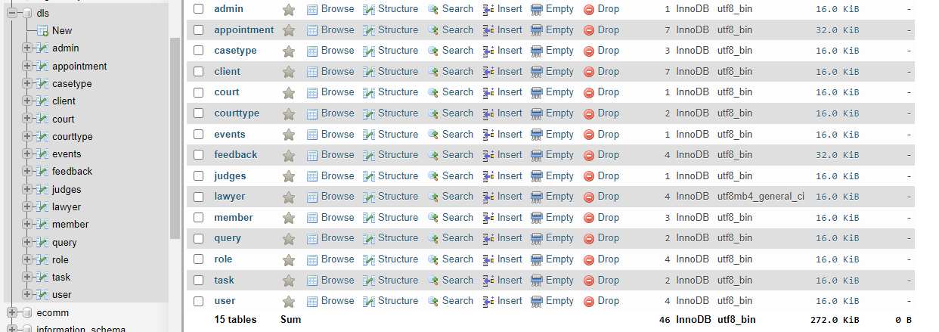

Figure 56: Database

## 6.20 Database Table Structure

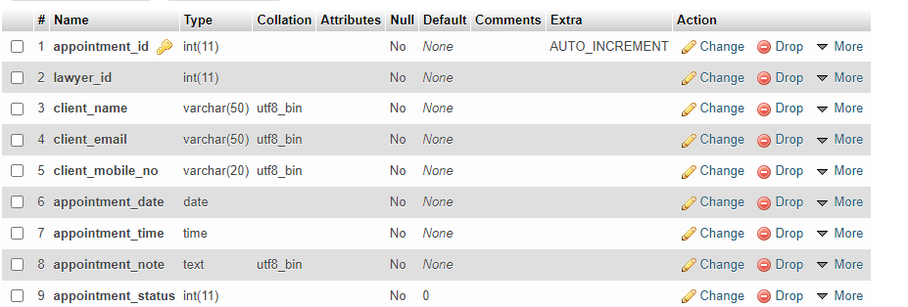

Figure 57: Table Structure